**TABLES WITH POPULATED DATA**

**Assignment Table**



**Review Table**



**Photo Table**



**Awards Table**



**Movie Table**



**Actor Table**



**Director Table**



**TV Shows Table**



**User Table**



**Part 5**

**Using SQL-based queries, prepare a report that summarizes and**   
**synthesizes business operations. Use any visualization of your choosing to**   
**present your results.**

1. **Top 3 "crime" TV Shows based on votes**

select show_title, show_genre, show_votes

from Tv_shows

where show_genre= 'crime'

order by show_votes DESC

LIMIT 3;

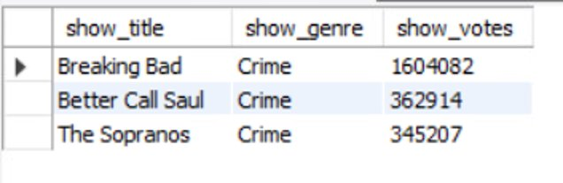

In this query, we are trying to understand the top 3 TV shows that are of “crime” genre and “Breaking Bad” came top, followed by “Better Call Saul” and “The Sopranos”.

1. **Top 3 movies based on earnings**

select movie_title, movie_genre, movie_earnings AS 'Earnings in Milions USD'

from Movie

order by movie_earnings DESC

LIMIT 3;



Here, we wanted to see the best selling movies so far based on earnings and “The Dark Knight” came out as the Movie with the highest amount earnings generated.

1. **Number of movies by genre in the database**

select movie_genre, count(movie_genre) AS 'Count'

from Movie

group by movie_genre

order by count(movie_genre) DESC;

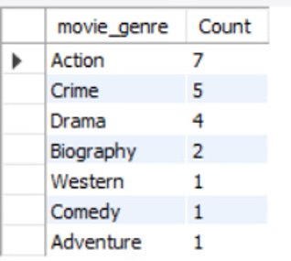

In this query, we are trying to see the distribution of Movies genre based on count and we identified that “Action” movies are the most popular movies in our database.

1. **The query below shows the no. Of movies actor performed in descending order.**

SELECT a.Actor_Name AS "Actor Name", count(m.Movie_Title) As "No. of Movies Performed"

FROM ACTOR a JOIN Assignment g ON a.Actor_Id = g.Actor_Id JOIN Movie m ON g.Movie_Id = m.Movie_Id

GROUP BY a.Actor_Name

ORDER BY count(m.Movie_Title) DESC;

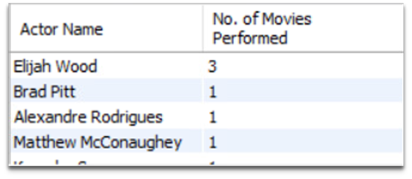

In this query we can identify the no. Of movies performed by each actor and in the output we can observe that Elijah Wood has performed in 3 different movies while others have acted in a single movie.

1. **This query calculates the no. Of seasons for each show which have been completed to date**

SELECT Show_Title AS "Show Title", (Show_End_Year - Show_Start_Year) AS "No. of Seasons"

FROM TV_Shows

WHERE Show_End_Year is not null;

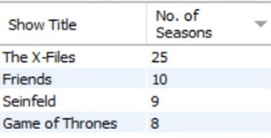

In this query we are trying to obtain shows which have been concluded and the no. Of seasons of each concluded show, we can observe that the X files has the highest no. Of seasons followed by Friends and other TV Shows.

1. **No. Of times Actors have been nominated but did not win the awards.**

SELECT ac.Actor_Name AS "Actor Name",count(aw.Award_Result) AS "Awards Won"

FROM Actor ac JOIN Awards aw ON ac.Actor_ID = aw.Actor_Id

WHERE aw.Award_Result = "Nominee"

GROUP BY ac.Actor_Name;

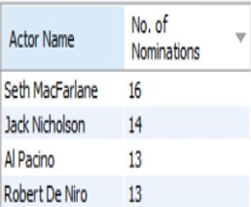

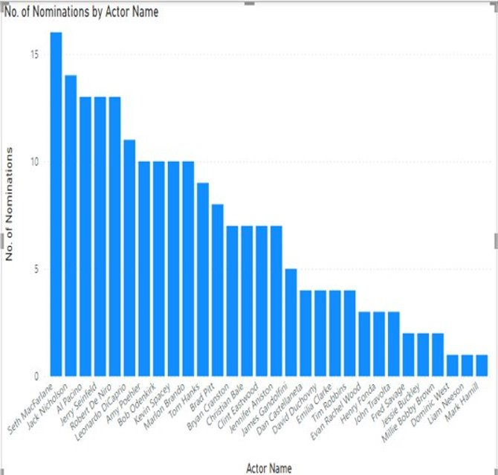

This query gives us information on the no. Of nominations actors have had and we can see that Seth MacFarlane has the highest no. Of nominations but he has only won 5 awards as observed in query 8. Similarly, this way we can compare the no. Of nominations and awards won for various actors.

1. **Displaying Shows which have not been completed yet.**

SELECT Show_Title AS "Show Title", Show_Start_Year AS "Show Start Year"

FROM TV_Shows

WHERE isnull(Show_End_Year);

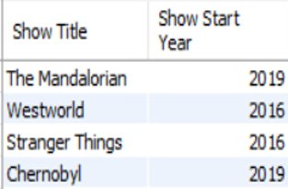

This query gives information about different shows which have not been concluded yet along with their show’s start year.

1. **Number of awards won per actor while also displaying their birth year**

SELECT Actor_Name, Actor_DOB, COUNT(Award_Result) AS "Total Awards Won"

FROM ACTOR ac, AWARDS aw

WHERE ac.Actor_Id = aw.Actor_Id

AND Award_Result = "Winner"

GROUP BY Actor_Name, Actor_DOB

ORDER BY COUNT(Award_Result) DESC ;

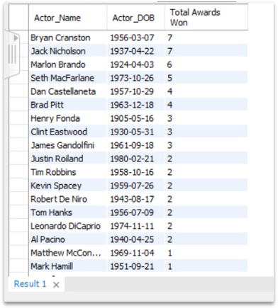

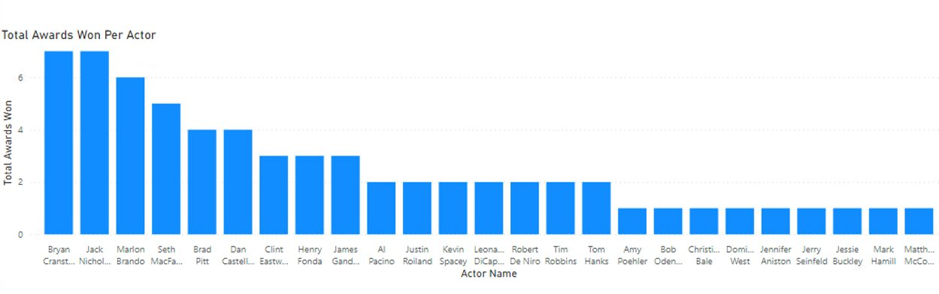

We can see Bryan Cranston has won the most awards out of the actors from the top 20 Movies and Shows. The bar graph shows the breakdown of all actors who have won major awards.

1. **Top TV Shows that have a high star rating, are intended for mature audiences, have a credible number of votes, has concluded, and has more than a 3 year running period.**

SELECT Show_Title, Show_Plot_Description, Show_Votes, (Show_End_Year - Show_Start_Year) AS "Show Duration in years"

FROM TV_SHOWS

WHERE Show_Star_Rating > 9.0

AND Show_Votes > 350000

AND Show_Age_Restriction = "TV-MA"

AND (Show_End_Year - Show_Start_Year) > 3

GROUP BY Show_Title, Show_Plot_Description, Show_Votes, (Show_End_Year - Show_Start_Year)

ORDER BY Show_Votes DESC;

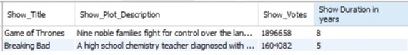

We see that Game of Thrones and Breaking Bad are the two highly recommended shows after conducting the analysis. They both have a star rating of above 9.0, have more than 350,000 votes, are intended for mature audiences and have a show duration of more than 3 years.

1. **The query below will display directors, the movies they directed, and their star ratings that are above or equal to 9.0. Based on the output we discover that there is only one director who appears twice on this list. When this output is compared to the data, there are several directors who appear more than once, but only one appears twice with the filters created in the following query.**

SELECT Director_Name, Movie_Title, Movie_Star_Rating

FROM Movie m, Assignment a, Director d

WHERE m.Movie_Id = a.Movie_Id

AND a.Director_Id = d.Director_Id

AND Movie_Star_Rating >= 9

ORDER BY Movie_Star_Rating DESC, Director_Name;

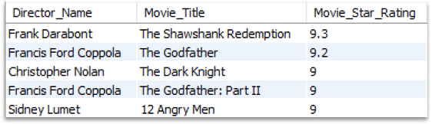

Based on the output and the filter we created using the query we discover that there are 4 different directors and 5 different movies in the table populated. When we compare this output with the original dataset with top 21 movies, there are several directors who appear more than once. However, Francis Ford Coppola is the only director that appears twice from the query we created. Therefore, we would recommend watching movies by Francis Ford Coppola and the other directors including Christopher Nolan to our users.

1. **The following query will display details of TV shows that have a rating of 8.5 and above with an average review length of above 250. We discover that there are only three TV shows that have a high rating with a higher average review length.**

SELECT s.Show_Id, Show_Title, Show_Star_Rating, Show_Votes, AVG(LENGTH(r.Review_Text)) AS Review_Length

FROM TV_Shows s, Review r

WHERE s.Show_Id = r.Show_Id

AND Show_Star_Rating > 8.5

GROUP BY Show_Title

HAVING Review_Length > 250

ORDER BY Show_Star_Rating DESC, Review_Length DESC;

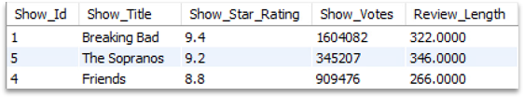

Based on the above query, we discover that there are only three TV shows that have a high rating with a higher average review length. Out of the 21 TV shows in our database, we will recommend these 3 shows based on their rating, votes, and average review length from users.